TEAM NUTRITION WEBSITE FOR CACFP

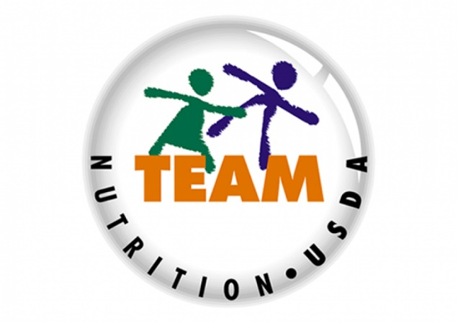

https://www.fns.usda.gov/tn/child-care-organization

Team Nutrition provides:
- Resources
- Menu planning items
- Materials
- Posters
- Webinars
- Recipes
- And Much More!

